LOAN APPLICATION

Screen Shots:
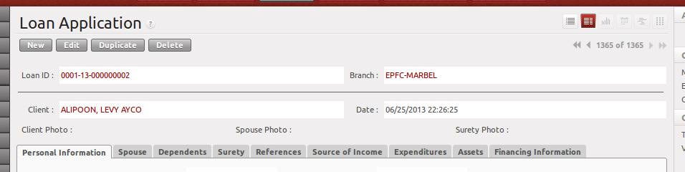

Personal Information
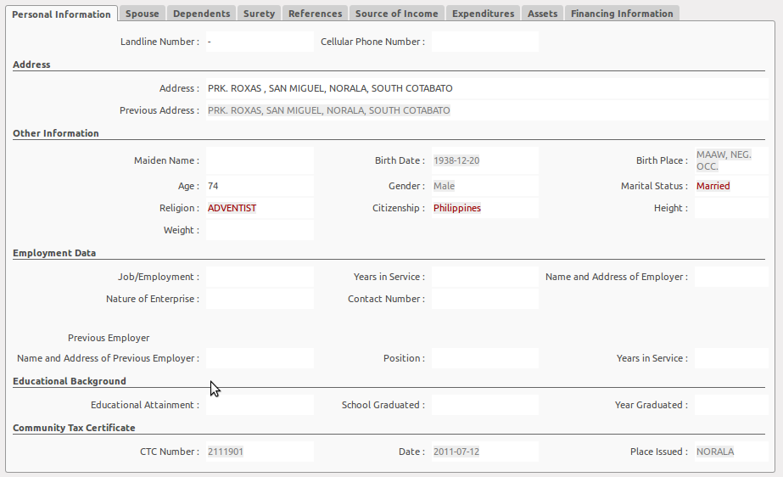
Address and Other Information are automatically saved to Client Information. So when the client will apply for another loan, these information will automatically be reflected. You just have to validate if the information is correct.

Spouse
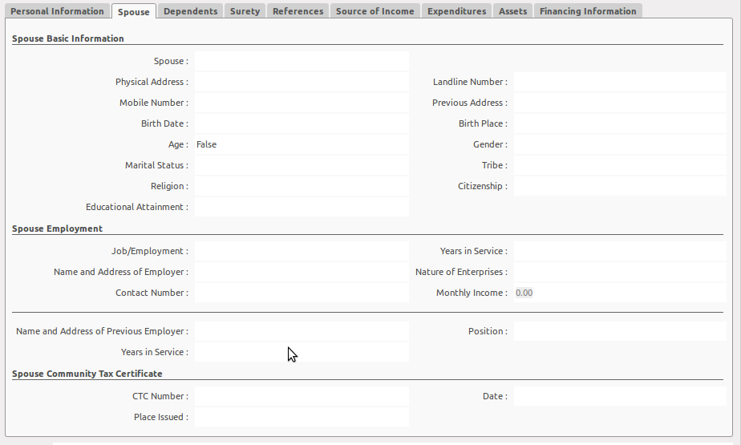
Spouse information is also saved in Client Information except Spouse Employment and CTC Information.

Dependents

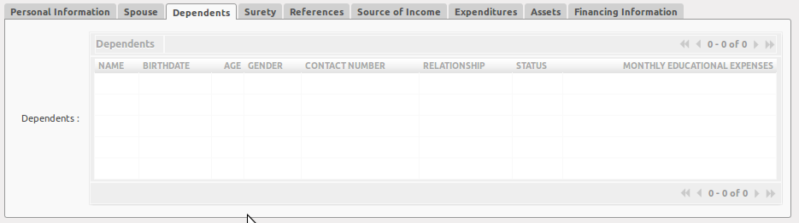

Surety
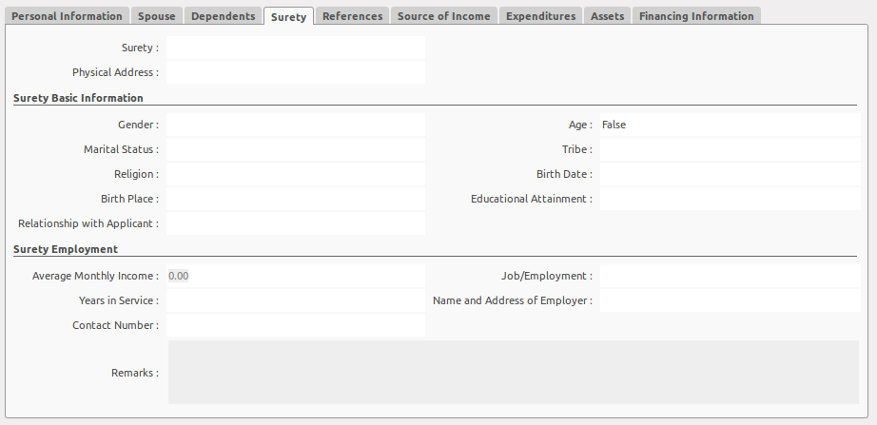
Surety information is also saved in Client Information except Surety Employment.

References

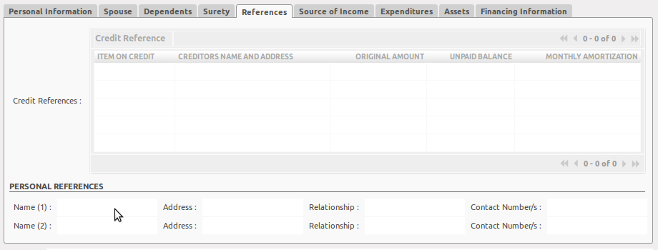

Source of Income
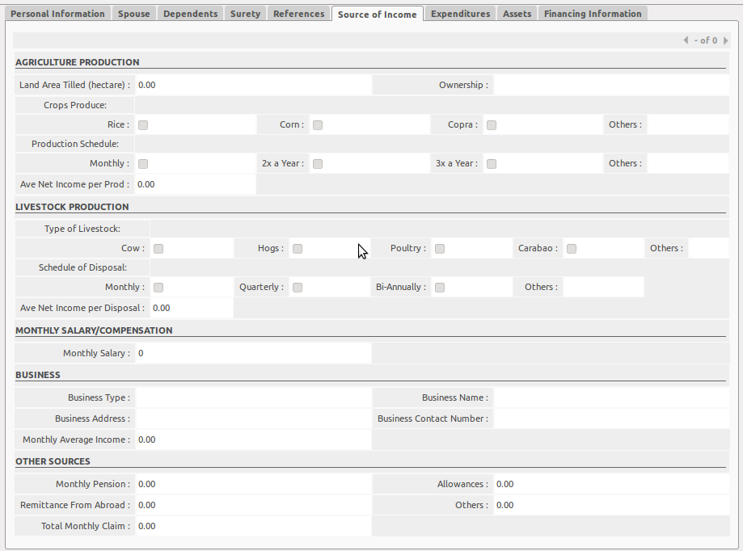

Expenditures

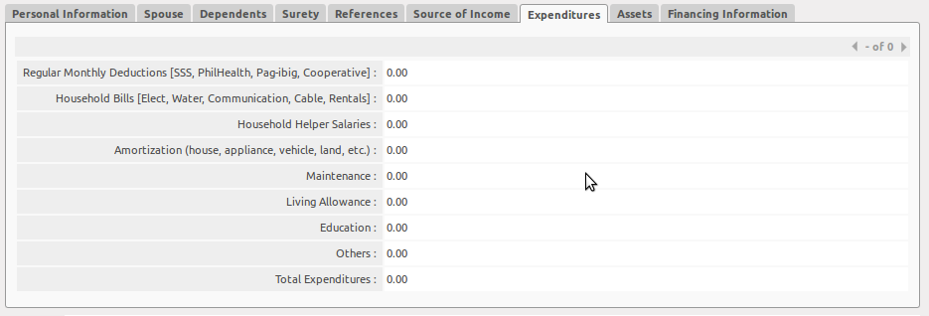

Assets
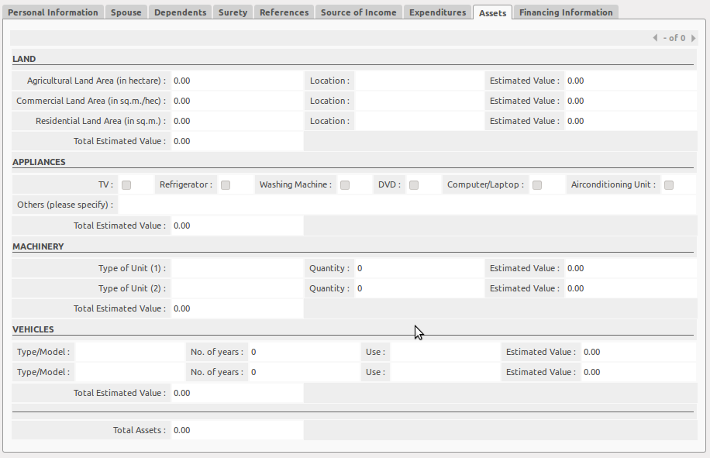
Financing Information

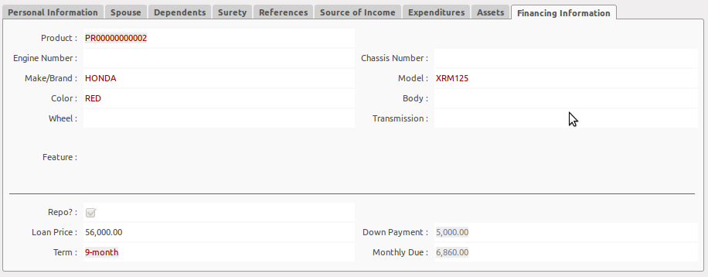
This financing information is from Inquiry. But if the customer has changed its mind at this point, you can edit the Financing Information as long as the Loan Application is on the DRAFT state.

Buttons
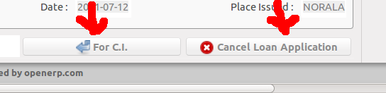
FOR CI Button
Once clicked, it will update the loan application status to “For C.I.” and will automatically add a new record to Credit Investigation.

Cancel Loan Application Button
Will update the loan application status to “Cancelled”.

Validations
- the records shown in tree view is filtered depending on the branch where the user is assigned.
- You cannot create a new record in loan application by clicking the new button. The creation of new record will always be initiated from INQUIRY module.

